INTRODUCING ‘HOUSE BLEND’
AT THE OTHER HOUSE SOUTH KENSINGTON
The Other House South Kensington introduces ‘House Blend’, the Residents Club’s new, elevated culture and events calendar for 2024; from VIP DJ sets and aperitivo hours, to jazz brunches and exclusive behind-the-scenes access to the Royal Albert Hall

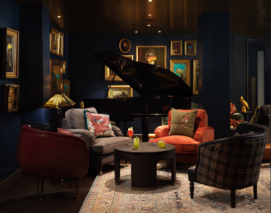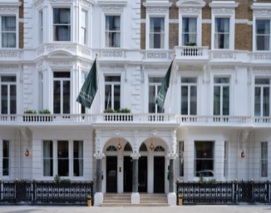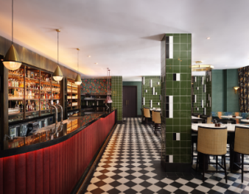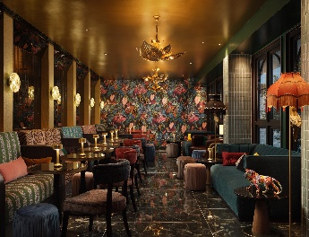
January 2024: This year, the cultural heartbeat of South Kensington is set to quicken with the launch of ‘House Blend’, the new 2024 culture and events calendar curated exclusively for The Other House South Kensington.
A stone’s throw from some of the world’s best-known cultural establishments, The Other House South Kensington has become the place to be for the cultural connoisseur since the chic Residents Club opened its doors in July 2022. ‘House Blend’ is set to raise the bar on the offering for its residents, members and guests, across both its public areas, including their street café, The Other Kitchen, and destination cocktail bar, the Owl & Monkey, and its exclusive private club.
‘House Blend’ comprises a mix of culture, learning, live performance, gastronomy and holistic wellbeing, both regular and one-off events. Whether it is being serenaded over brunch by some of London’s leading musical talent, gearing up for the weekend with a cocktail and live DJ, gaining exclusive, behind-the-scenes access to the Royal Albert Hall, learning a new skill such as sustainable candle making or enjoying a meditative sound bath, the evolving and imaginative list of activities is set to thrill and delight those visiting for the evening, staying for the weekend or residing for the year.
An overview of all the new activity, both on the public-facing side of The Other House South Kensington and within the private club, are as follows:
Public Areas
Available to Book: The Other Kitchen, the Owl & Monkey, the Library
Each week, 'House Blend' promises an immersive journey through cultural and gastronomic experiences, embracing the vibrant soul of South Kensington.
During the week, the chic Owl & Monkey bar, offers ample opportunity to enjoy some of its signature sustainable cocktails, whether during Happy Hour on Monday and Tuesday, delectable aperitivo on Wednesday evening, or for those looking to up the ante on a Friday evening and pair up cocktails with music from a resident list of VIP DJs.
At the weekend, The Other House South Kensington offers a feast for body and soul with its indulgent brunches in The Other Kitchen. Perfect for those looking for chilled vibes and good food, Sundays are now served with a side of live jazz and breakfast cocktails at the newly-launched Jazz Brunch.
Private Club
Members and residents only: The Keeping Room and Hogsmire lounges, and The Other Space wellbeing and fitness facilities
Members and residents of The Other House South Kensington who have exclusive access to the private club, are in for a treat with the exciting calendar of events and exclusive partnerships offered.
The private club serves as a sanctuary for discerning members seeking a blend of sophistication and cultural enrichment. In the relaxed lounge spaces, The Keeping Room and Hogsmire, the launch of ‘House Blend’ includes opportunities for members to immerse themselves in the soulful melodies of live jazz vocalists and pianists and engage in thought-provoking panel discussions with industry-leading minds.
For those looking for something more restorative, ‘House Blend’ also includes an extensive calendar of wellbeing experiences in The Other Space, the wellness facilities at The Other House South Kensington. Whether OM Sound Healing sessions through an exclusive partnership with sound artist, Leo Cosendai, in the presence of the UK’s largest gong, yoga classes or wellness experiences through resident partner Mamma Wellbeing, residents and members can utilise The Other Space as a genuine retreat in the city.
Rates at The Other House South Kensington start from £300 per night for a Club Flat. Aiming to become ‘your other house for a long as you’re in town’, stays at this Residents Club can range from one night to a year or more; residencies of any length include access to its exclusive private club. To book, visit www.otherhouse.com.
-ENDS-
The Other House
PR Manager: Callum McLellan-Attfield
callum@otherhouse.com
www.otherhouse.com
Notes to Editors:
THE OTHER HOUSE SOUTH KENSINGTON
South Kensington is the inaugural opening from The Other House, a revolutionary hospitality concept combining apartment-style living with hotel services, and a private club available to residents as well as local members. Consisting of 237 Club Flats, ranging from cosy studios through to striking apartments, The Other House South Kensington opened in July 2022.
Fast-becoming a key social and cultural hub, offering exclusive partnerships with local institutions such as the Royal Albert Hall, The Other House South Kensington offers everything a discerning city lover could want. Facilities include the all-day brunch destination, The Other Kitchen, the chic cocktail bar, the Owl & Monkey, and the exclusive private club, available to members and residents, with two club lounges and The Other Space which offers a range of state-of-the-art wellbeing, mindfulness and fitness facilities.
THE OTHER HOUSE BRAND:
The Other House is tearing up the rule book and launching a new sector of Residents Clubs, redefining the hospitality market. It effortlessly combines apartment-style living with hotel services and access to an exclusive private club. Think pied-à-terre meets private club, available for all residents to enjoy. It is cool, intriguing, bold and committed to sustainability. Whether it’s for a day or a year, it is your other house for as long as you are in town.
Launched in 2019, The Other House is a joint venture partnership between London Central Portfolio (LCP), leading real estate investment advisory in Prime Central London and APG, the largest pension provider in the Netherlands. The Other House opened in South Kensington in July 2022, with Covent Garden opening early 2025 and plans for Belgravia in the pipeline. Further openings in London and internationally are also in the works.
Learn more about The Other House here www.otherhouse.com.

